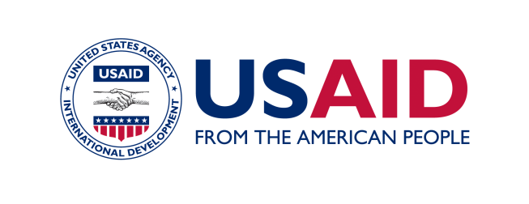
Global Health Evidence Summit

Community and Formal Health System Support for
Enhanced Community Health Worker Performance

- Global Health Evidence Summits
President Obama’s Global Health Initiative (GHI) emphasizes the critical importance of evidence-based best practices to inform country owned, sustainable improvements in health outcomes. Informing evidence-based effective sustainable health systems is, likewise, essential to achieving the GHI health targets. Integral to USAID’s reform efforts under the GHI is a renewed emphasis on evidence-based approaches to inform GHI activities including practice, policy, and strategy. Yet, development challenges are complex, intrinsically multidisciplinary, and therefore informed by diverse data inputs and expertise.
To that end, USAID is hosting a series of evidence summits. The purpose of these summits, in contrast to traditional conferences, is to bring together academics and US Government (USG) development practitioners to address some of the world's most difficult development challenges. Global Health Evidence Summits reflect USAID’s commitment to evidence-based innovative, efficient, effective, global health programs. The rapid application and scale up of novel discoveries and health innovations to populations needing them the most requires a continuum of learning from basic to operational research combined with practitioner and program experience that engages a broad coalition of contributors across the USG, academics, host countries, and GHI country teams.
USAID is committed to inclusive leadership and multidisciplinary participation to facilitate the quality and productivity of each summit. The intended users of the information derived from the Evidence Summit are low and middle income country governments (LMICs), USG policy and program decision makers, and other multilateral stakeholders. Both of these audiences will benefit from evidence-informed recommendations on how best to support community health workers to improve their performance.
Expected outcomes from each GH summit include:
- Clarity on evidence to inform programs and policies
- Identification of knowledge gaps to inform a research agenda
- Publication and dissemination of findings and recommendations.
- Evidence to action follow-up to ensure application of learning and active pursuit of critical knowledge gaps.

- Overview: Evidence Summit on Community and Formal System Support for Enhanced Community Health Worker Performance
The global shortage of skilled, motivated, and supported health workers is universally acknowledged as a barrier to the Millennium Development Goals. The World Health Report 2006, “Working Together for Health,” estimated that there is a shortage of 4.3 million health workers in the world. To help alleviate this shortage, many countries are implementing large- scale community health worker (CHW) programs to extend the reach of services to underserved populations. Several health workforce campaigns launched in 2011 called for more and better-supported health workers, of which at least a million are CHWs.
Yet, “better support” for CHWs must be evidence-based to ensure optimal performance and utilization of resources at all levels. CHWs receive support from both the community they serve as well as from the formal health system. The sources of community and the formal health system support vary by context, as do their support, which are intended to improve CHW performance.
Possible Sources of Community Support  - village health committees  - religious leaders  - social support networks  - CBOs/NGOs  - multi-sectoral organizations  - political and governance leaders/groups | Possible Sources of Formal Health System Support  - facility-based public providers  - facility-based private providers  - supply chain personnel  - Ministry of Health personnel
Types of Community and Formal Health System Support Interventions
supervision, mentorship, incentives, positioning of CHWs in the community

The CHW is a key actor at the intersection of these two dynamic and overlapping systems (Figure 1). The Evidence Summit will examine the types of community and formal health system support activities that are intended to improve CHW performance, and how this support is provided. Of particular interest is how the two systems interact to influence CHW performance.
The Principal Hypothesis of the CHW Evidence Summit
The combined effect of community and formal health system support activities on improving CHW performance is greater than the effect of either alone.

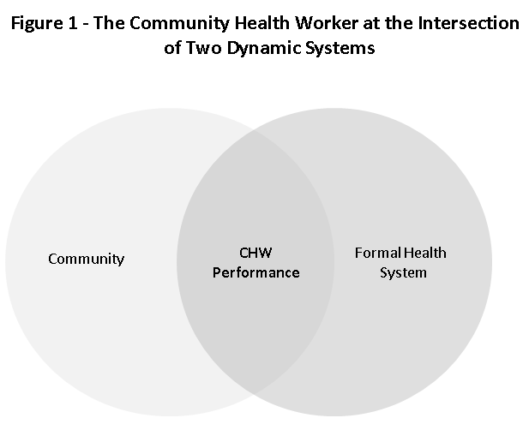
CHW performance can be defined in different ways. For the purpose of this summit, we have defined effects on performance in three ways: proximate, intermediate, and distal effects. All three effect categories will be included in the analysis. Proximate effects include a range of measures that relate directly to the individual CHW: his or her knowledge, competency, self-efficacy, self-esteem, legitimacy, prestige, advancement, absenteeism, attrition and quality of practice. Here, a particular focus will be given to the quality of community health worker practice. It is assumed that the quality of CHW practice is the sum result of other proximate measures (i.e. self-efficacy, attrition, legitimacy/credibility, etc.), and that good quality performance, among all these measures, is the one farthest along the pathway toward the achievement of intermediate and distal measures of improved performance. Intermediate effects are those that are measured in the populations served by the CHWs: coverage with high impact interventions, care-seeking behavior, health-promoting practices in the home and community, and changes in medical care brought about by CHW performance. Distal effects include CHW-attributable, population-based outcomes, such as morbidity, mortality, and fertility reduction; equity; and cost effectiveness.

- Why focus on the community and formal health system’s support and interaction for enhanced community health worker performance?

USAID/GH was asked to consider potential Evidence Summit topics using the following criteria:
- Enough evidence is available to permit policy/and or programmatic decision making.
- Rigorous studies or systematic analysis are adequately represented in the body of available evidence.
- The applications of evidence will likely result in high impact (health outcomes) and/or improved implementation of interventions.
- The topic is likely to inform GHI Principles and/or GHI targets.
- The evidence can be collected, synthesized, shared and discussed within a reasonable cost.
- Additional Guidance on the topic is needed.

The topic of effectively supporting sustainable, effective CHW performance met these criteria. USAID/GH was then asked to consider the following criteria to determine specific focal questions for the Evidence Summit in support:
- Questions are adequately focused so they can be answered.
- Answers to the questions are unknown or there is a lack of clear consensus on answers to the questions.
- Some evidence exists to evaluate answers to the questions.
- Answers to the questions would likely contribute positively to LMIC country government policies and programs USG programming for CHW programs in developing countries.
- Answers based on evidence would inform a corresponding research agenda.

- Focal Questions
Scoping exercise
To inform the development of focal questions, a sub-committee of the technical working group undertook a limited scoping exercise. The exercise comprised a review of USAID’s current activities in CHW programming and research, interviews with key informants, and a review of key papers. The exercise concluded that knowledge about what CHWs were able to achieve, optimal training, and the type of supports needed are fairly robust. However, the team identified a lack of clarity on the systems within which the community health worker functions and a need for guidance on how essential interventions were implemented. Further, the interaction between the community and the formal health system to enhance effectiveness of community health workers is not well understood. Thus, USAID/GH chose to focus the evidence summit on the optimal support from the community and formal health system and the potential synergies that may enhance existing and future CHW programs in LMICs.
Assumptions
Several independent variables of interest appear to affect CHW performance, other than community and formal health system support activities. Those additional variables include CHW characteristics, patient characteristics, service mix, the nature and complexity of the service package delivered, and contextual factors, among others. For the purposes of this summit, those variables will not be the focus of the investigation but addressed as appropriate when interpreting evidence.
Focal Questions
Focal Question 1: Which community support activities improve the performance of community health workers?

- Belief: Specific community support activities positively affect CHW performance.
- Context: Community support to improve CHW performance need additional characterization. What these support activities are and how they are optimally implemented appears to vary within effective systems. Characterizing these support activities further will assist in assessing the interaction between the community and formal health system.

Focal Question 2: Which formal health system support activities improve the performance of community health workers?

- Belief: Specific formal health system support activities positively affect CHW performance.
- Context: Formal health system support activities to improve CHW performance are relatively well characterized. How these support activities are effectively and optimally implemented varies. Characterization of these support activities will assist in assessing the interaction between the community and formal health system.

Focal Question 3: Which combination of community and formal health system support activities improve the performance of community health workers?

- Belief: Community health worker performance requires specific support from both the community and formal health system to effectively function in the community setting.
- Context: Research and evaluations around CHW performance have largely focused on characterizing specific support activities, such as training, or supply chain, or connection with the formal health system rather than viewing CHW performance as supported by two intersecting and dynamic systems.

Focal Question 4: How are community and formal health system support activities structured and/or operationalized to improve CHW performance?

- Belief: Identification of optimal community and formal health system support is not adequate to positively impact CHW performance. To enhance performance specific guidance and or information about optimal and sustainable implementation of support activities is needed.
- Context: The literature scoping exercises have revealed a paucity of data around implementation of such support activities.

Information from Questions 1 and 2 will inform the more interesting issue of the combined effect and optimal implementation of each intervention addressed in Questions 3 and 4.

- Overview of the Evidence Summit Process

The Evidence Summit on Community and Formal Health System Support for Enhanced Community Health Worker Performance is more than a specific event; it is a multi-step process leading up to and following the meeting that results in important products and an evidence to action plan for implementation. This process involves the following:

- A Core Group of USG experts obtained informed advice from the broad scientific and technical community knowledgeable about CHW performance to determine the topics of importance that led to the development of a set of Focal Questions and the preparation of this Concept Paper.
- Going forward, the Core Group identifies experts in topics relevant to the Focal Questions and invites them to serve as members of an Evidence Review Team.
- The Core Group commissions a literature review and a Call for Evidence in which important documents relevant to the summit are identified and assessed for relevance and quality.
- The Evidence Review Team members are provided the database of documents and asked to review and rate a small set of documents based on relevance to the focal questions.
- Writing teams comprised of Evidence Review Team members, Core Group members and others draft reports and presentations for the summit
- The Evidence Summit will be held in late May, 2012 in the Washington DC area, at which time draft reports and recommendations are presented and discussed.
- Following the Evidence Summit, the writing teams will use the feedback from the summit to prepare final reports for publications in a peer reviewed journal.
- USG agencies and their partners, including country governments, other donors, and frontline workers themselves, develop an Evidence to Action plan to maximize the impact of the summit. Information generated during the summit is intended to be used to provide guidance on enhancing CHW performance to change health-related behaviors and improve health outcomes, policies, and programs to policymakers and governmental programmers and to the development community.

- Evidence Review Process, Insurance Relevance, and Expected Outcomes
Review process

USAID/GH will be leveraging a systematic review of health worker performance conducted by the CDC, which will be supplemented by gray literature as well as papers from a ‘call for evidence.’ The resulting literature will be sorted and experts will be asked to review and evaluate the evidence, write evidence summaries and generate conclusions and recommendations. This will be a systematic approach to the evidence, not a systematic review, which will include rigorous studies (experimental and quasi-experimental designs) that explicitly examine the effect on health worker performance of both community and formal health system interventions. Conclusions and recommendations will be based on the scientific evidence as well as practitioner knowledge and experience, products of monitoring and evaluation, operations research, development experience and insights into sociocultural contexts.

Ensuring the relevance of the summit to efficacious, effective, and sustainable health programs and policies in low- and middle-income countries

Evidence standards have evolved from the medical field where physician decision making is often tied to rigorous data derived from randomized controlled trials (RCTs) which prove efficacy of an intervention for the individual patient. Evidence requirements for global health programs are far more complex. In global programs the “evidence” must not only show efficacy at the individual level within a specific context (does it work in a narrowly defined context?), but also effectiveness at the community and population levels in differing locations and contextually varied environments (does it work in a variety of contexts?). Further, sustainability at the country level is critical for country ownership and feasibility. Sustainability refers to the strengthening of formal and informal health systems to ensure the quality and reach of short- and long-term health services and public health programs, and work with governments to ensure the continuity and coordination of their health programming. For host countries and donors, evidence on feasibility and cost-effectiveness are also critical to investment and resource allocation decisions.

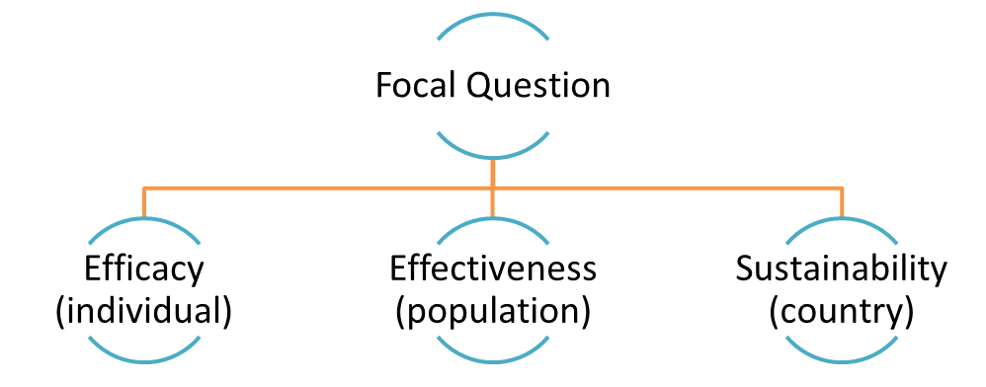
Accordingly, the ideal approach to evaluation of evidence must reflect the needs of global programming and include these three streams of relevant data: efficacy, effectiveness and sustainability. These streams of evidence typically result from different research approaches so varying methodologies are needed to evaluate the evidence. Most importantly, scientific evidence as well as program experience and expert opinion are needed.

These considerations serve as core principles in gathering the evidence for the summit, where it is essential to find out what is known about all three streams of evidence. The literature search and Call for Evidence will be designed to maximize the assembly of information on all three. In addition, ERT members will be asked to critically examine the evidence to ask not only whether certain strategies for improving CHW performance have been shown to work, but to ask if they have been shown to work in a variety of contexts and if they would be sustainable if scaled up for large scale adoption.

Expected outcomes

The expected outcomes from the Summit are as follows:

- Clarity on evidence to inform LMICs on community and formal health system support for enhanced CHW performance
- Identification of knowledge gaps which will inform a USG research agenda

Immediate follow-on activities are as follows:

- Establishment of programming principles and/or a technical strategy for USAID assistance to LMIC CHW programs
- An evidence-to-action strategy to guide application of learning and actively address critical knowledge gaps
- A publication documenting findings, programming principles and an evidence-to-action strategy.

- Evidence to Action

As articulated, the aim of evidence summits is to bring together diverse thought leaders to address complex development challenges. Health service delivery to communities in LMIC with high population to health service provider ratios remains a challenge facing the global health community and an obstacle to reaching the health related MDGs . Viewing community health service delivery and the CHW within the systems context enables a fresh evaluation of evidence in support of how to sustain effective delivery of health services involving CHW. The outcomes of this summit will include recommendations for LMIC governments and communities on implementation and strengthening of these systems and priorities for a research agenda to further strengthen health service delivery involving CHW.

It is hoped that the global health community, including the USG and LMIC governments, will utilize these evidence-based recommendations to envision a novel systems strategy and research agenda to support sustainable, effective health service delivery at the community level by maximizing the value of all systems inputs to improve CHW performance.

The GHI Evidence Summit defines a Community Health Worker as a broadly used term for a health worker who receives standardized training outside the formal nursing or medical curricula to deliver a range of basic health, promotional, educational and mobilization services and has a defined role within the community system and larger health system. These workers have many different titles, including but not limited to village health workers, health promoters, community health agents, community health extension workers, or traditional birth attendants, who serve as extensions of the formal health system.

