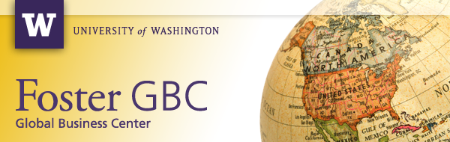
Foster School Home Page | News | Events | Invest in GBC
Make Social Change Your Business – Apply to the 8th annual 2012 Global Social Entrepreneurship Competition (GSEC)!

Applications opening July 2011. Application Deadline is Nov. 9, 2011

The Global Social Entrepreneurship Competition (GSEC) is a leading-edge international social venture plan competition, where interdisciplinary student teams from around the world propose innovative, commercially viable businesses aimed at reducing poverty in developing economies.

Monetary prizes will be awarded to the GSEC teams that develop the most innovative businesses with the best integration of financial and social returns on investment, including Information & Communication Technologies (ICT) and Global Health prizes.

GSEC business plans may focus on any subject area and it is open to currently enrolled students at any academic institution of higher education worldwide. Multi-disciplinary teams are strongly encouraged.

Why Participate?
GSEC provides cross-cultural, transformational practical learning experiences for student participants to hone their business skills, expand their networks, and access new resources.

Each year, GSEC brings the world to the University of Washington: a select group of semi-finalist student teams attend GSEC Week in Seattle where they visit regional companies, present their business ideas to judges, and compete for monetary prizes.

Watch the GSEC video for an overview.

How to Apply
Review the Rules & Prizes webpage.

Need a team or team member? Post an announcement on the GSEC Facebook discussion board.

About GSEC
GSEC Week provides exclusive opportunities for semi-finalist teams to benefit from invaluable resources and expertise in the Seattle region: every year over 150 professionals volunteer as mentors, judges, and sponsors, providing critical expertise and resources. Individuals volunteer from organizations such as: Costco, Gray Ghost Ventures, Microsoft, PATH, the Bill & Melinda Gates Foundation, Smith Barney, Seattle International Foundation, the Grameen Foundation, the Washington Global Health Alliance, and UW Department of Global Health.

GSEC is organized by the University of Washington’s Global Business Center at the Michael G. Foster School of Business, with the support of prize sponsors Microsoft and the UW Department of Global Health.

Contact gsec@uw.edu with questions.



Think globally. Make a difference.  It's the Washington Way.  THIS NEWSLETTER WAS SENT BY:  Global Business Center  Michael G. Foster School of Business, Box 353200, Seattle WA 98195-3200  © 2011 University of Washington | Contact Us | Privacy Policy  Manage Your Subscriptions or Unsubscribe | 

