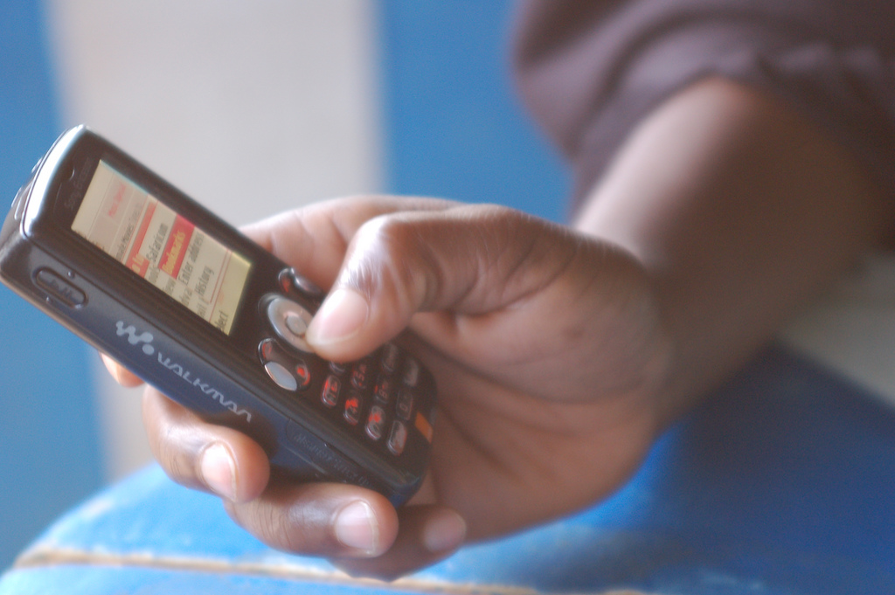
Photo © White African
Four Students, Four Countries, Four Perspectives: A Roundtable Discussion of Technology, Business, and Youth in Namibia, Ghana, Cameroon, and South Africa.
Wednesday, October 26 - Communications Building Room 202 - 3:00 – 4:30 PM
Sponsored by the UW African Studies Program
Moderated by MCDM Associate Director Anita Verna Crofts

MCDM Student Shelby Barnes spent the summer in Namibia observing the impact digital media is having on Namibian culture, business, and youth, and mentoring interns at one of the country’s top advertising agencies, adforceDDB.
MCDM Student Pam Kahl spent four weeks this past summer in Ghana concurrently teaching a storytelling seminar at Ashesi University, Ghana’s first liberal arts curriculum institution of higher education, and exploring the use of Information Communication Technologies (ICT).
MCDM Student Joseph Pavey spent this last summer working in Cameroon as a Technology Advisor for Plan International on their Youth Empowerment Through Technology, Arts, and Media (YETAM) project. YETAM teaches skills in social media, citizen journalism, and digital mapping to help make youth better advocates for change and development in their own communities.
MCDM Alum Alvin Singh works with entrepreneurs in South Africa who are looking for interactive marketing methods to boost sales and reach a broader consumer base. He primarily studies how mobile technology is moving rapidly across Africa and the different behavior habits of subscribers particularly—particularly youth. In addition, Singh works closely with legendary photographer Alf Kumalo to digitize over 60 years of his photos, and was given press access to follow First Lady Michelle Obama on her first solo trip to Africa.

