We are seeking a dynamic
Founding Head of School
Effective June, 2010

Mission of the Gashora Girls Academy

The mission of the Gashora Girls Academy is to inspire young women to become intellectually courageous and the future leaders of Rwanda.

Vision of the Gashora Girls Academy

The vision of the Gashora Girls Academy is to deliver the highest quality education to girls from across the country of Rwanda, who would otherwise not likely have the opportunity to pursue secondary education.

The graduates will be empowered, critical thinkers who are responsible and compassionate citizens. Graduates will strive to attend university and be prepared to contribute productively to their community and a changing world.

The institution will be highly regarded for its focus on academic excellence, innovative teaching practice, leadership and a spirit of empowerment, community service, and global awareness.

Values

Integrity, respect, responsibility and trust are the core values that all the stake holders in the school must share, to accomplish the school’s mission and sustain its vision.

The School

The Gashora Girls Academy is a new, independent secondary girls’ boarding school located in the Bugesera District of Rwanda, about an hour outside of Kigali, the capital city of Rwanda.

The campus is comprised of approximately 28 acres, 1/3 of which is allocated to the school and 2/3 of which is allocated to agriculture. Additionally, there is a community center on site which is intended to be shared between the school and village of Gashora.

The school campus consists of high quality, culturally relevant, modern facilities that include student dormitories, a dining hall with attached kitchen facilities, class rooms, science and technology labs, and sports fields.

The agricultural land is intended to serve as a demonstration farm for the community of Gashora, supply food to the school and to provide revenue for support of the school’s operational budget. In addition, it is envisioned that the land would be used to support the school’s curriculum (science, vocational skills).

The Community Center will have a stage for school/community performances, an indoor basketball court, a computer kiosk and kitchen.

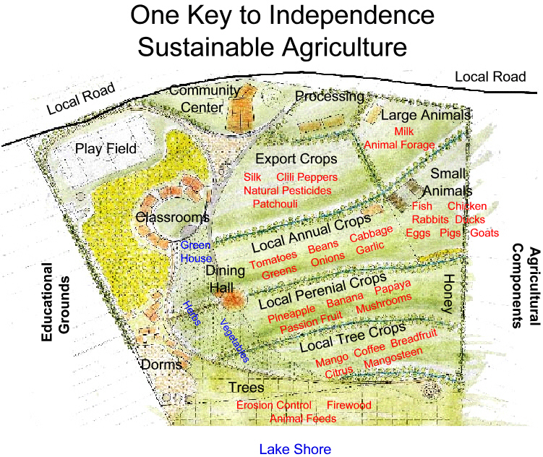

Governance & Leadership

The Head of School is responsible for the organization, operation and administration of all aspects of the Gashora Girls Academy and reports to the RGI Board of Directors. The Head of School will have the unique opportunity to launch and lead the school; hire staff and teaching faculty and to play a key role in developing the school culture and relationships with the greater community.

Curriculum

The school will follow the Rwandan National Curriculum (www.mineduc.gov.rw). However, we will look to the Head of School to develop and implement curriculum intended to enhance and supplement the Rwandan National Curriculum. Using innovative teaching methods, our goal is that the graduates would also finish their schooling with vocational, leadership and life skills training upon graduation.

Courses will be taught in English.

Upon graduation students will be required to pass a national exam to determine university placement.

Teaching Faculty

The Head of School will play a critical role in hiring 10 teachers from both inside and outside of Rwanda; ultimately, building a dynamic team to deliver a quality educational experience.

Student Enrollment

The Gashora Girls Academy will educate 270 Rwandan girls in upper secondary education (US equivalent of grades 10,11, and 12). The students will be selected both through a national exam measuring achievement, as well as through a lottery of applicants showing exceptional potential. Admissions will draw girls from across the country as well as from the immediate Gashora community. The school will open in January 2011 with the first class of 90 students and will add 90 students each of the next two years. Courses will follow the Rwandan School year which begins in January and ends in November.

The Position: Founding Head of School, Gashora Girls Academy

The Head of School has primary responsibility for leading and managing the Gashora Girls Academy.

- Provide academic leadership through staff recruitment, curriculum development, and management of school day to day operations.

- Create a school culture that supports the mission of Gashora Girls Academy.

- Oversee financial standing and compliance with Gashora Girls Academy budget parameters.

- Work with RGI Board of Directors and the local board to develop a strategic plan for the school.

- Maintain a close working relationship with RGI Board of Directors. Ensure RGI board is appropriately briefed at all times on policy, legal questions, and significant operational issues.

- Serve as the primary representative of the school when interfacing with the community, Ministry of Education and other agencies within Rwanda.

- Develop Gashora Girls Academy as a model that will prepare students for university and post graduation opportunities.

Preferred Candidates will have:

- Strong familiarity and love of Africa (experience in a developing country highly desirable)

- Proven experience managing business and financial aspects of a school

- Experience working in or managing an international school, a girls’ school and/or a start-up school

- Ability to inspire and articulate the vision of the school, fostering strong working relationships with teaching colleagues, board members and other key partners

- Creative and inspired leadership with strong decision making skills

- Entrepreneurial spirit with ability to solve problems

- Comfortable working and living in a beautiful rural setting

- Graduate degree in Education

- Capable of identifying and combining US teacher talent with teachers from Rwanda to form a strong team

- Sensitivity and understanding of Rwandan culture and history

- Confident ,flexible, and motivated

Terms

- Competitive Salary

- Initial contract will be for 3 years

- Benefits will include: Private residence on campus, allowance for one trip home per year, health insurance, use of school vehicle and facilitation of an initial shipment of personal items

Application Process

- We look forward to hearing from you at the earliest possible time, but no later than December 1st, 2009

- Letter indicating why Heading the Gashora Girls Academy is of interest, including Statement of Philosophy and management style

- Resume & three references (email, phone, address)

- Send all documents in electronic format to sfoster@rwandagirlsinitiative.org

Additional Background

The Gashora Girls Academy is the first school to be launched by the Rwanda Girls Initiative.

Rwanda Girls Initiative (RGI) was established in 2008 as a 501(c)3 to create educational opportunities for girls who qualify for and yet might not otherwise have the opportunity to pursue a secondary education.

RGI has developed a unique model to build a secondary girls’ boarding school. The model will be based on creating the appropriate infrastructure so that the school will be independent financially of RGI within seven years. The RGI model has been developed around key partnerships, and community involvement to create diverse streams of revenue which will eventually sustain school operations. Financially, the school will be supported by revenue from tuition, scholarships, the Rwandan Government, as well as the community driven businesses created using our agriculture land as the origin of development.

The school is the first sponsored by the Rwanda Girls Initiative and thus will play a critical role in modeling and delivering quality education, while empowering girls with leadership and life skills that they will be able to carry with them through university and into the productive careers of their choosing.

Additional information on the Gashora Girls Academy and the Rwanda Girls Initiative at www.rwandagirlsinitiative.org

